Task 1

#Various Functionalities of the completed TODO blocks

File: main.py

#TODO loss function:

Loss function is defined as:

criterion = nn.BCELoss().cuda()

This is the Cross Entropy Loss function for two variables.

#TODO optimizer function:

optimizer = torch.optim.SGD(model.parameters(), args.lr,momentum = args.momentum, weight_decay = args.weight_decay)

SGD - This is the Stochastic Gradient Descent. Does gradient descent over mini batches of data

#TODO: Model Output:

heatmap = model(input_var)

Model is the network output.

#TODO: Visualization:

Calculating the heatmap of the model’s output by performing a 2D max pool followed by sigmoid.

#TODO logger for visdom and tboard

Creates logging directory for tensboard and visdom

#TODO Training loop

File : custom.py

def find_classes(imdb):

This function returns 2 outputs. Classes list include the list of 20 classes in the string form

namely aeroplane etc. Classes dictionary includes the list of classes (string) and it’s index (int).

def make_dataset(imdb, class_to_idx):

This function takes in imdb (train/test etc.) and class_to_idx. In output it maps the pathlist and

the imagelist. We can convert it to set and see that each values in the corresponding lists maps

to each other sequentially.

class LocalizerAlexNet(nn.Module):

def __init__(self, num_classes=20):

Here we divide the model in 2 parts (Both are sequential N.N.)

1. Features:

It contains 4 blocks of conv layers. First 2 blocks has conv2d, Relu and Maxpool layers

and the last 2 blocks are conv2d and maxpool layers.

2) Classifier:

It contains 3 blocks. First 2 blocks include conv2d and relu and last block includes just

conv layer.

def forward(self, x):

In the first line, the image is passed through the features layer followed by the classifier layer. We are returning the key points of the object detected in the heatmap.

def localizer_alexnet(**kwargs):

This function takes in argument, True or False. If the pretrained is True, we will take the pretrained weights from the Alexnet for the layers that are defined under “Features”. Then irrespective of the input arguments, we will do xaviers initialization for the classification layers irrespective of the .

def localizer_alexnet_robust(pretrained=False, **kwargs):

This function takes in argument, True or False. If the pretrained is True, we will take the pretrained weights from the Alexnet for the layers that are defined under “Features”. Then irrespective of the input arguments, we will do xaviers initialization for the classification layers irrespective of the .

def __getitem__(self, index):

This function reads the Image with the given index. Applies the transform (target_transform) and return the image and label.

# Dimensions

Output resolution for the model → 32 x 20 x 29 x 29

Output of the heatmap is → 29 x 29

Q1.4

Xavier initialization has been used for initializing the weights. As the training proceeds, the weights get trained resulting in drop in loss. Due to the initialization, the loss is quite high but it drastically goes down as training progresses.

# Metrices Dimensions

**def metric1(output, target):**

The first metric is Mean average Precision (mAP) which is used for multi label classification. Higher the MAP score is better the performance. This is calculated based on set of classes and Ground Truth.

**def metric2(output, target):**

This metric defines the recall function.

* Training screenshot of tensor board metric1, metric2 on the training set

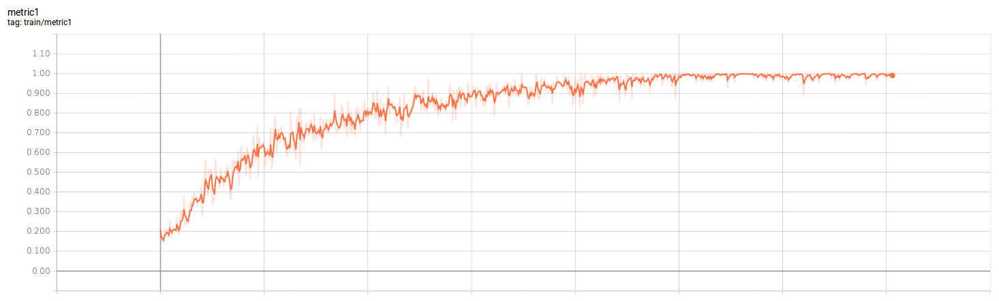

Metric 1 training

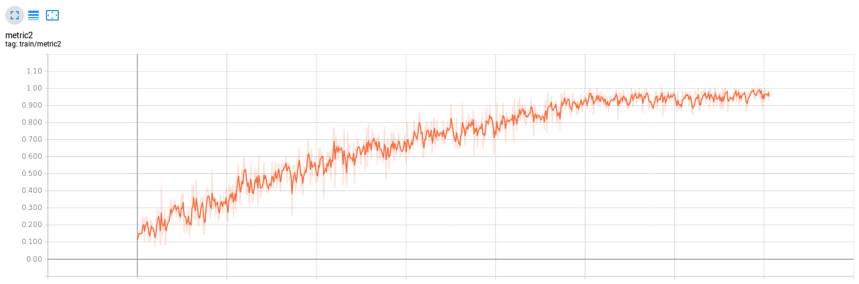

Metrics 2 training

* [ ] Add screenshot of tensor board metric1, metric2 on the validation set

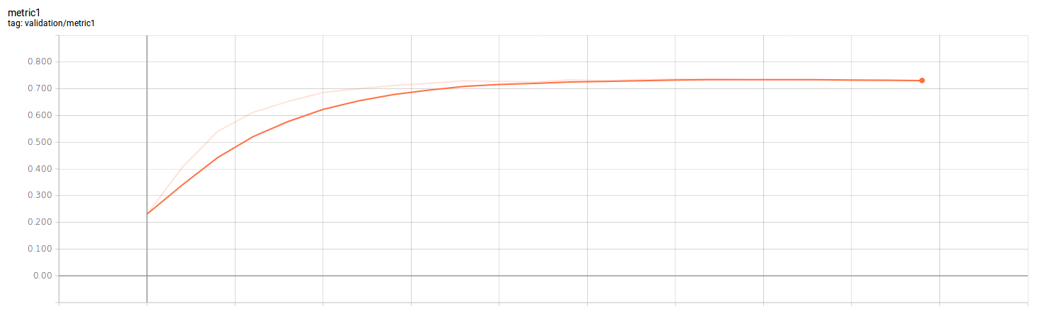

Metrics 1 validation

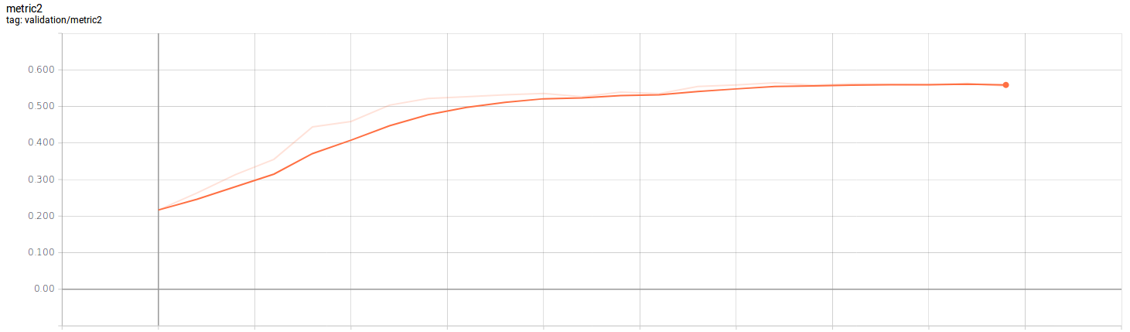

Metrics 2 validation

* [ ] Screenshot of tensor board showing images and heat maps for the first logged epoch

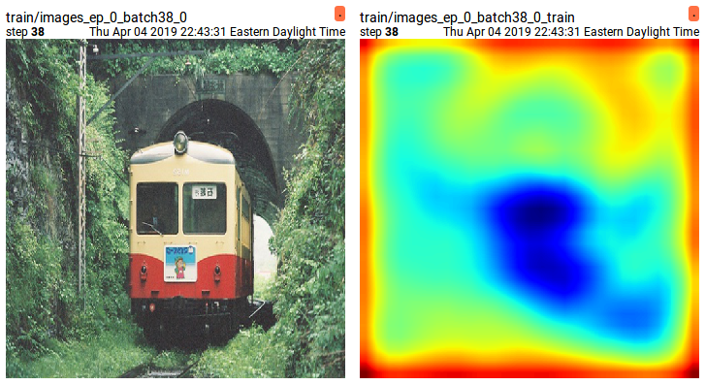

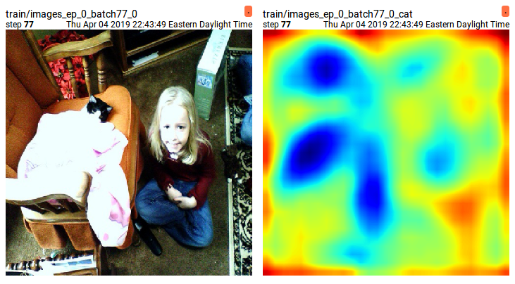

* [ ] Screenshot of tensor board showing images and heat maps for the last logged epoch

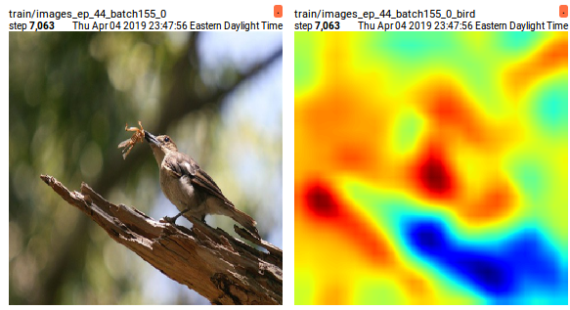

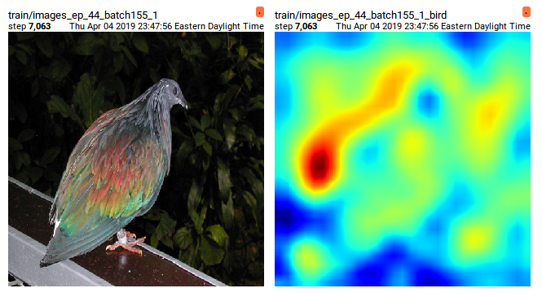

* [ ] Use visdom filter in the browser to search for the first logged epoch, include screenshot

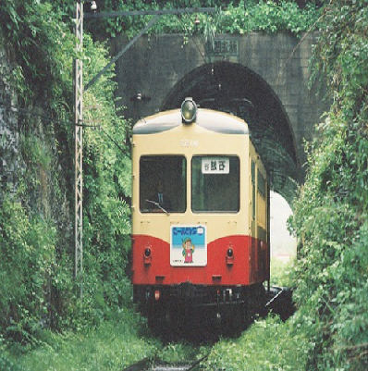

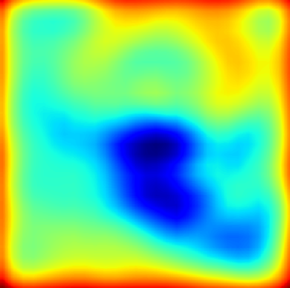



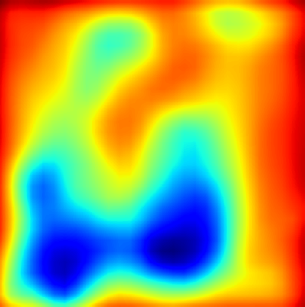

* [ ] Use visdom filter in the browser to search for the last logged epoch, include screenshot

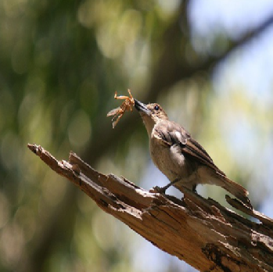

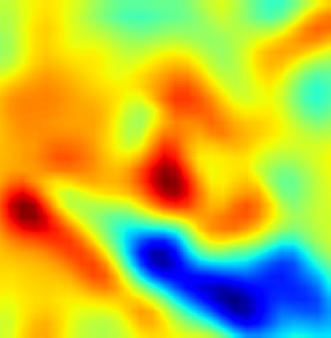

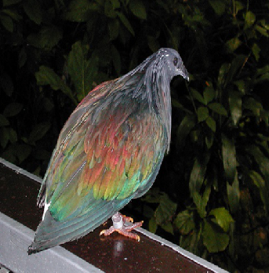

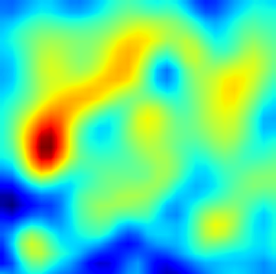

* [ ] Visdom screenshot for 20 randomly chosen validation images and heat maps



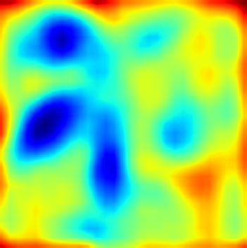

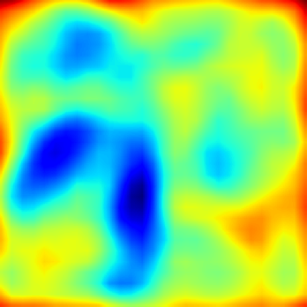

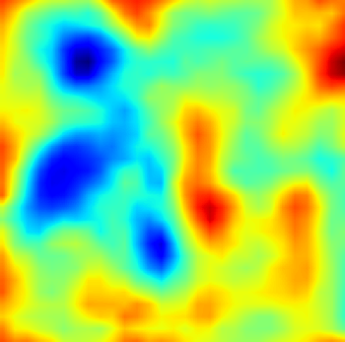

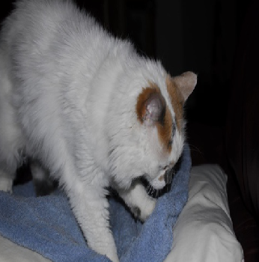

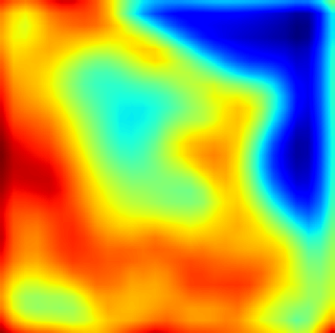

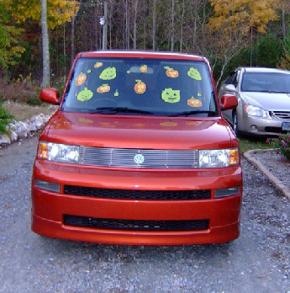

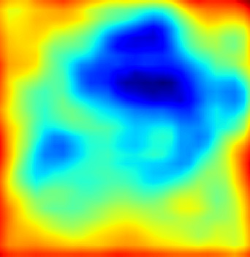



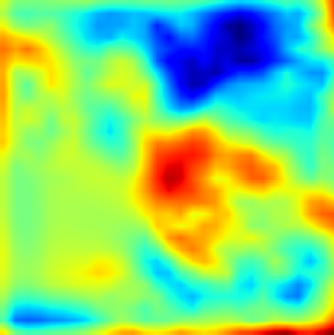

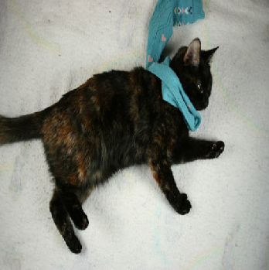

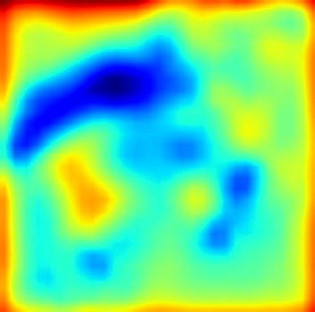

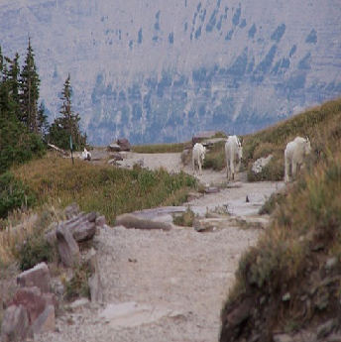

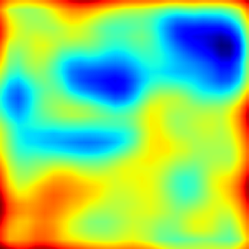

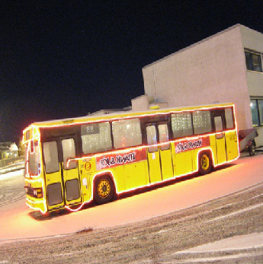

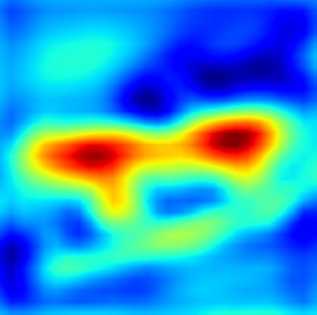

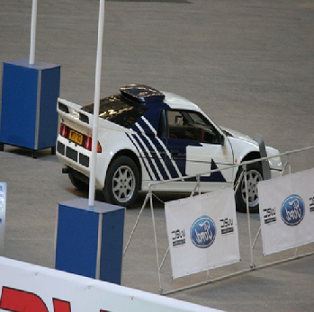

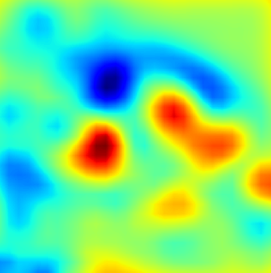

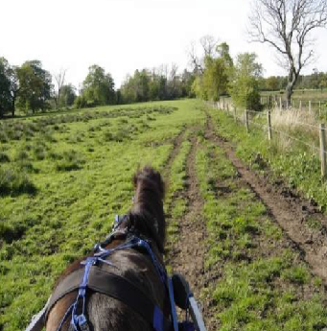

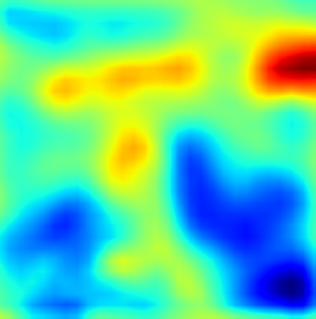

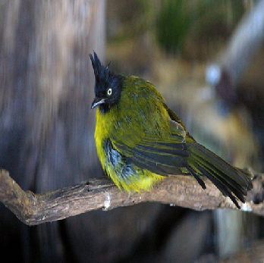

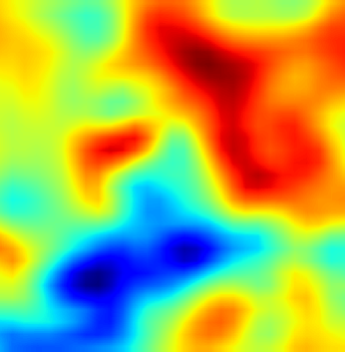

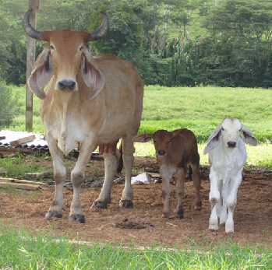

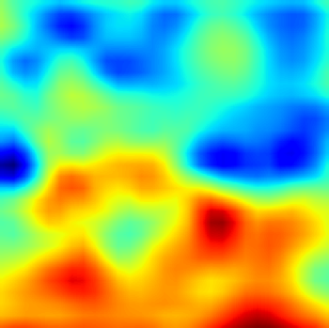

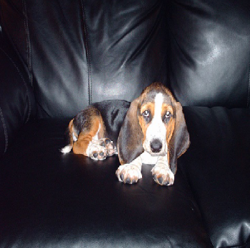

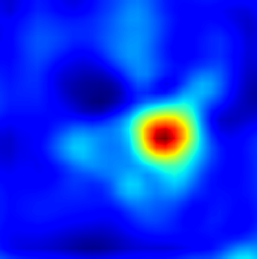









* [ ] Report training loss, validation metric1, validation metric2 at the end of training

Training Loss: 0.06

Training - Metric 1 (mAp): 0.93

Training - Metric 2 (Recall): 0.81

Validation - Metric 1 (mAp): 0.77

Validation - Metric 2 (Recall): 0.70

Q1.7

**#TODO Explanation:**

**class LocalizerAlexNetRobust(nn.Module):**

**def __init__(self, num_classes=20):**

In the previous model it was seen that the detection (heatmaps) was only seen on the key features of the objects but not on the whole object. But if we take the averaging of those points we may detect the object as a whole on the heat map. The model remains the same.

**def forward(self, x):**

Here we do the avg_pool2d over the output. This will give the heatmap not just on the key features of the objects but on whole of the object.

**def localizer_alexnet_robust(pretrained=False, **kwargs):**

Here everything is same as in the previous function. If the pretrained is True (that is our case) we will take the pretrained layers from the Alexnet for the layers that are defined under “Features”. Then irrespective of the pretrained boolean values, we will do xaviers initialization for the layers in the “Classification”. Here by initialization I mean initializing the weights.

* [ ] Screenshot of tensor board showing images and heat maps for the first logged epoch *for Q1.6 and Q1.7 side-by-side*.

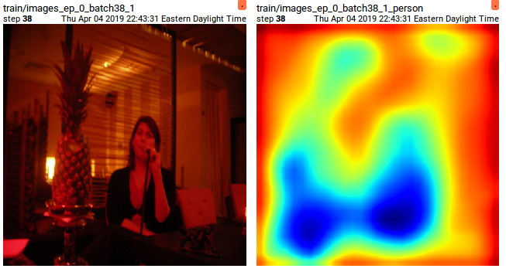

Q1.6

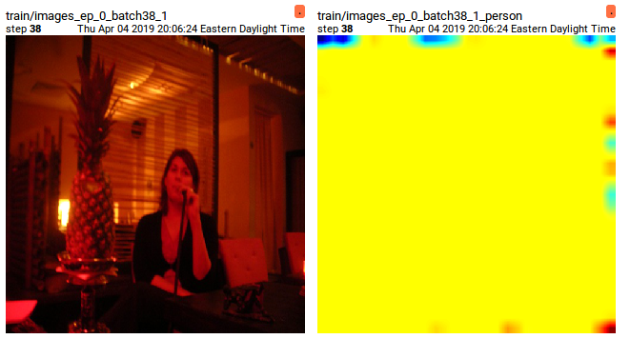

Q1.7

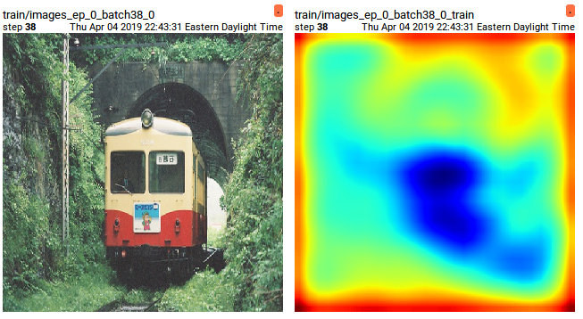

Q1.6

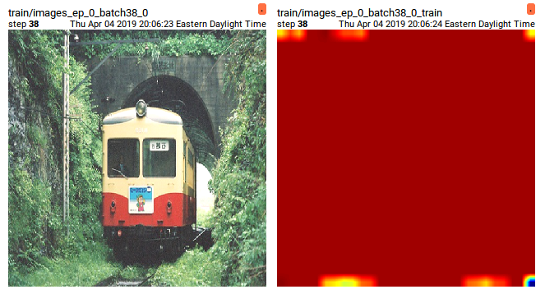

Q 1.7

* [ ] Screenshot of tensor board showing images and heat maps for the last logged epoch *for Q1.6 and Q1.7 side-by-side*.



Q 1.6

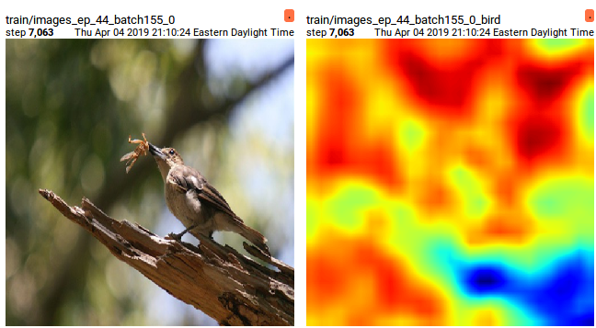

Q1.7



Q 1.6

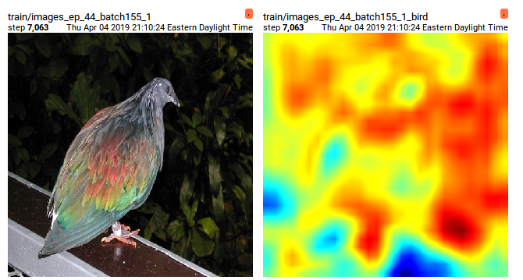

Q1.7

* [ ] Visdom screenshot for 20 randomly chosen validation images (but same images as Q1.6) and heat maps



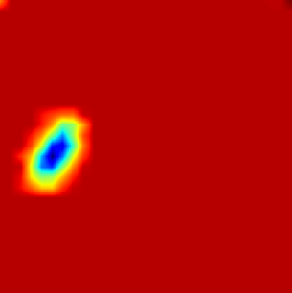

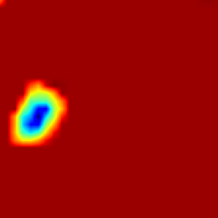

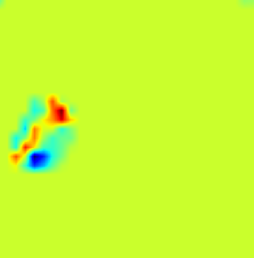

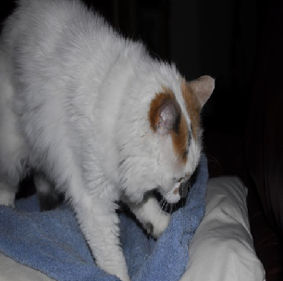

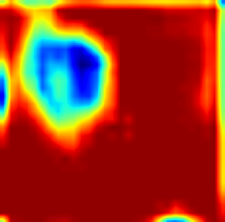

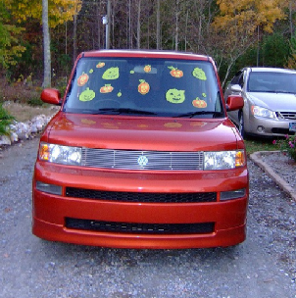

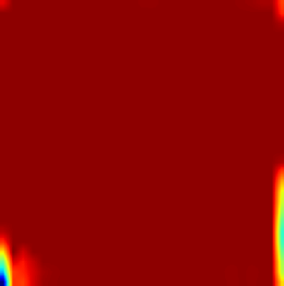



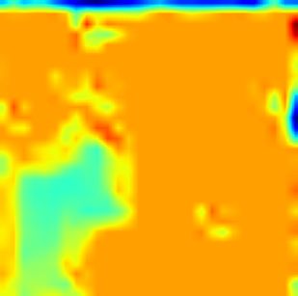

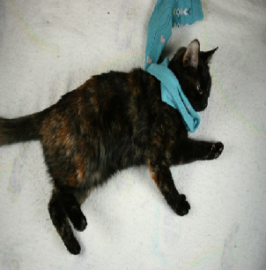

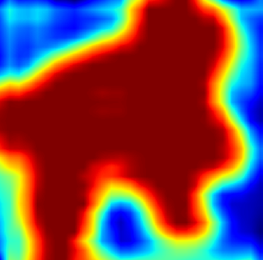

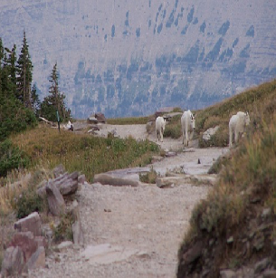

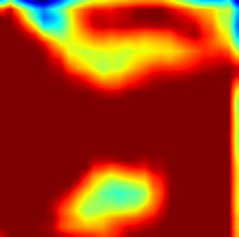

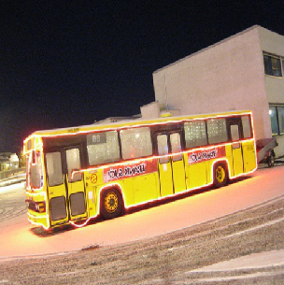

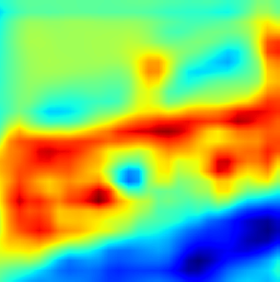

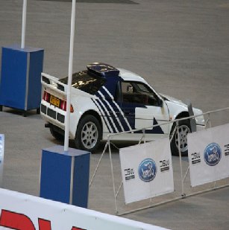

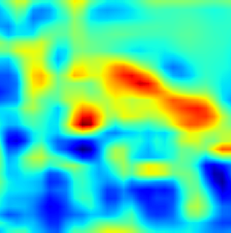

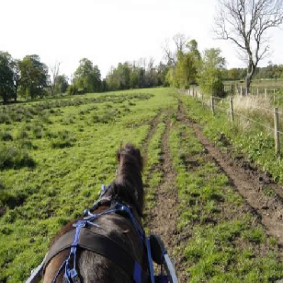

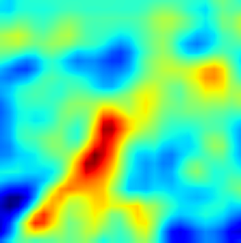

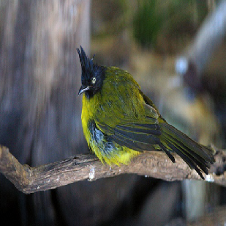

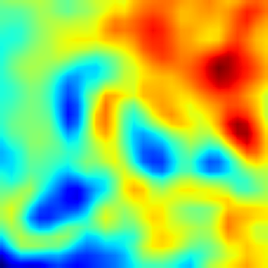

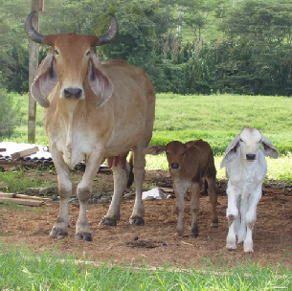

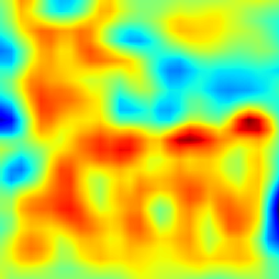

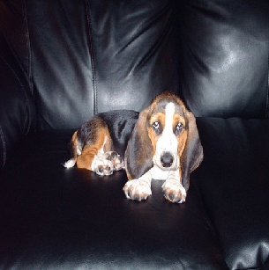

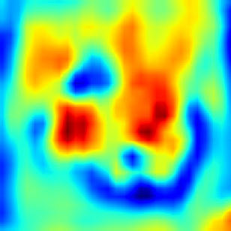

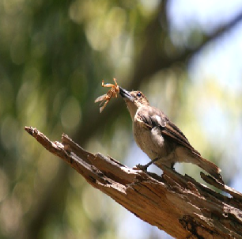

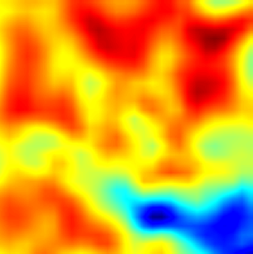

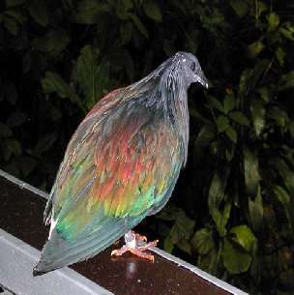

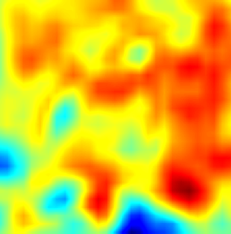

* [ ] Report training loss, validation metric1, validation metric2 at the end of training

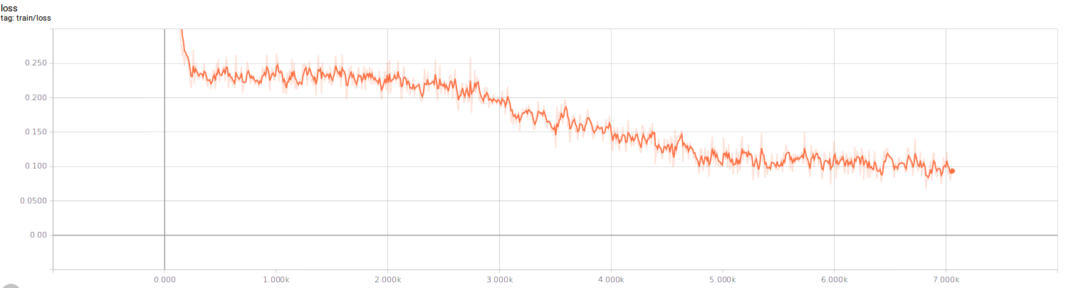

Training loss

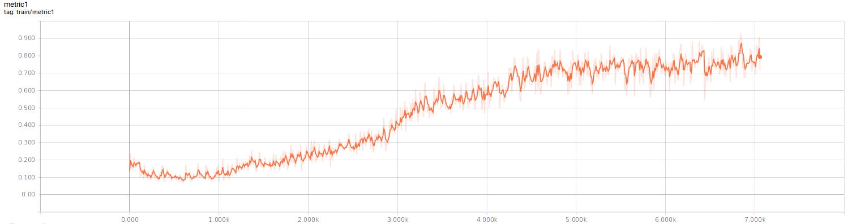

Training metric1

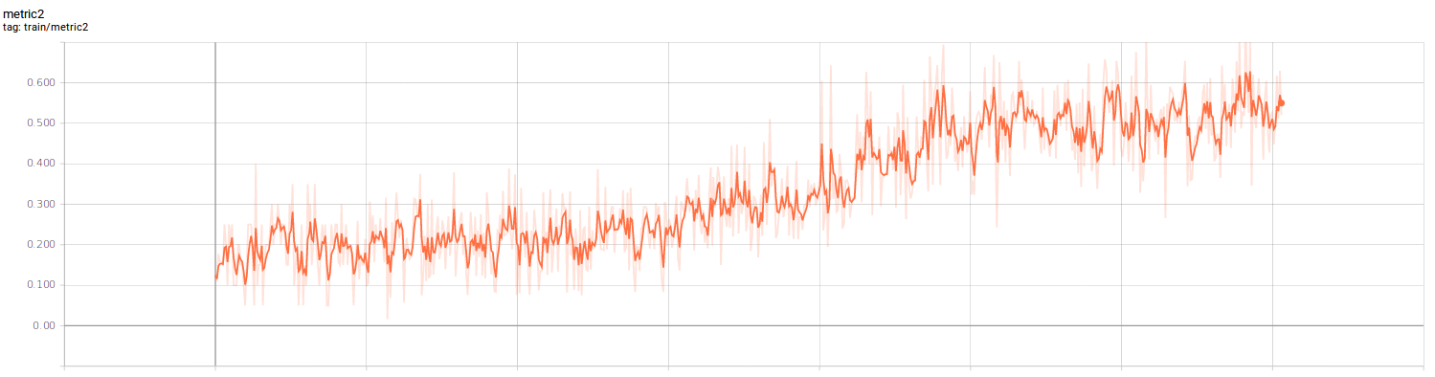

Training metric2

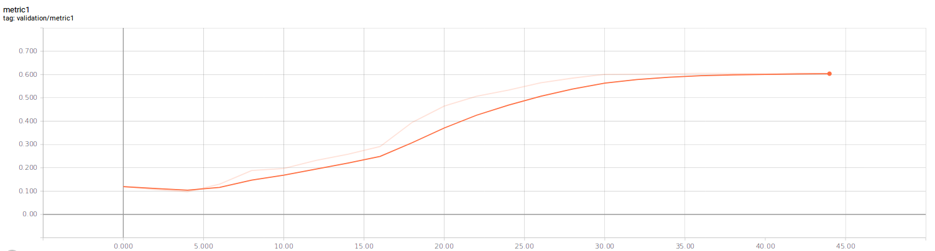

Metric1 Validation

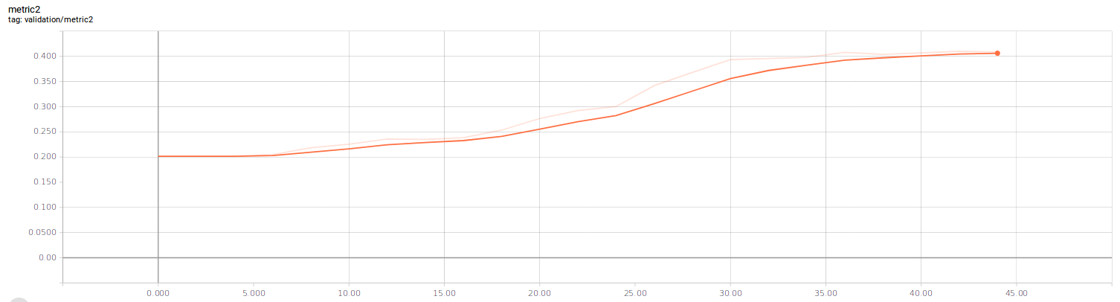

Metric2 validation

Training Loss: 0.09841

Training - Metric 1 (mAp): 0.7910

Training - Metric 2 (Recall): 0.52

Validation - Metric 1 (mAp): 0.6051

Validation - Metric 2 (Recall): 0.4085

Q2.

* [ ] Q2.4 visdom downloaded image of training loss vs iterations
* [ ] Q2.4 tensor board screenshot of training loss vs iterations

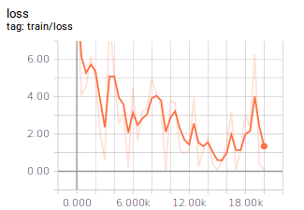

* [ ] Q2.4 tensor board screenshot histogram of gradients of weights for conv1, conv2 and fc7

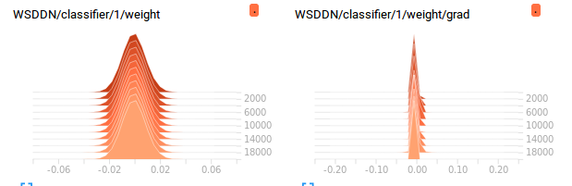

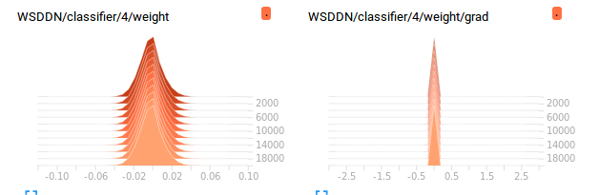

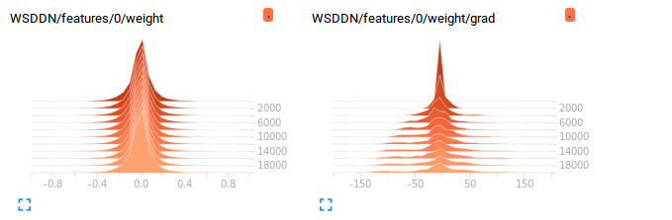

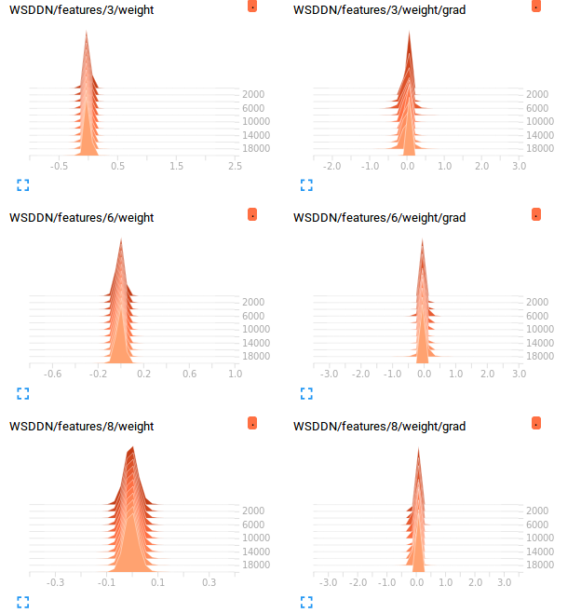

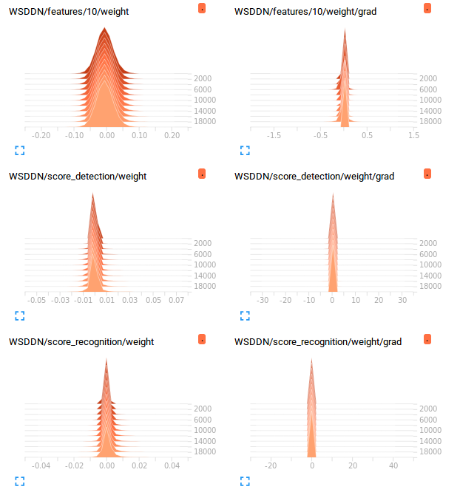

* [ ] Q2.4 visdom downloaded image of test mAP vs iterations plot
* [ ] Q2.4 tensorboard screenshot for class-wise APs vs iterations showing 3 or more classes

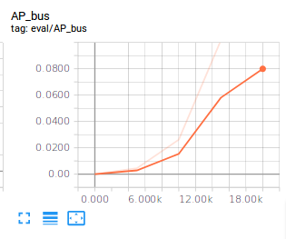

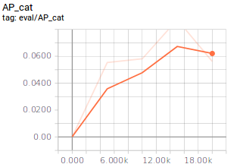

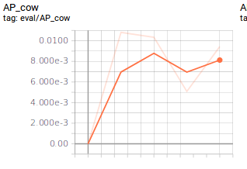

* [ ] Q2.4 tensor board screenshot of images with predicted boxes for the first logged iteration (5000)

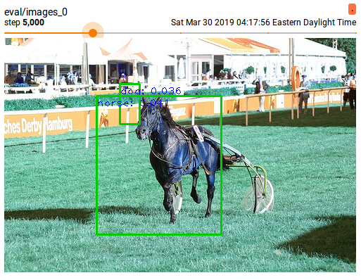

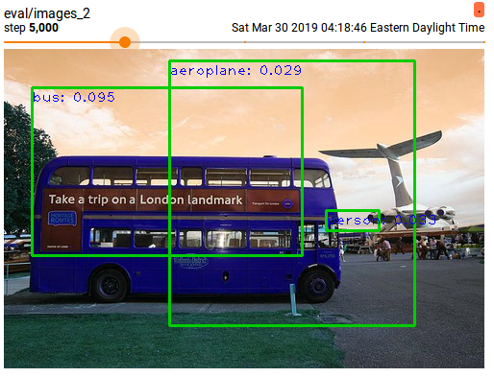

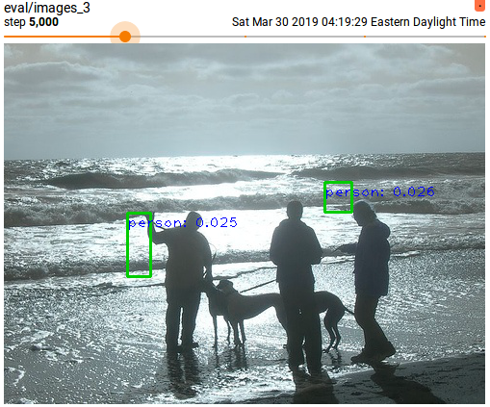

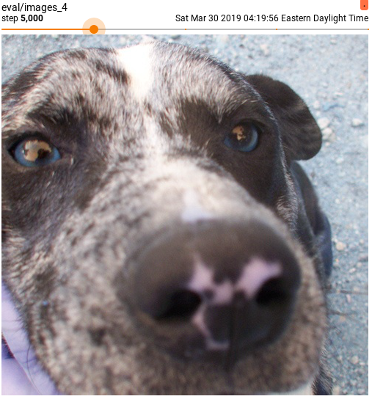

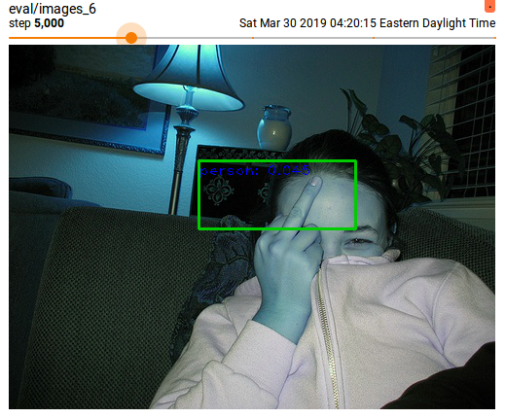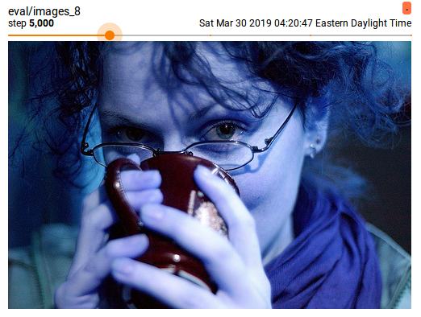

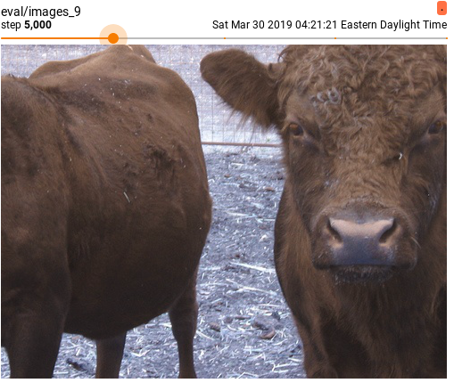

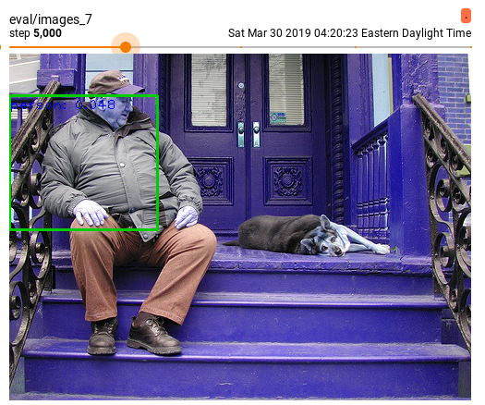

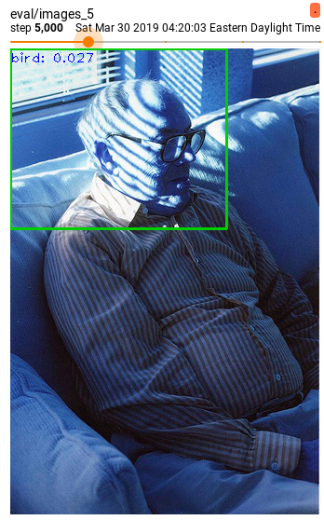

* [ ] Q2.4 tensor board screenshot of images with predicted boxes for the last logged iteration

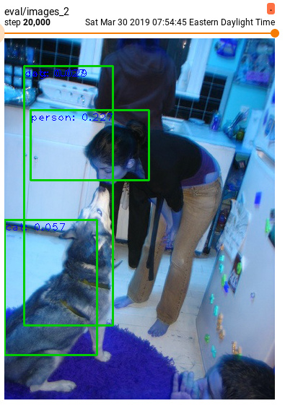

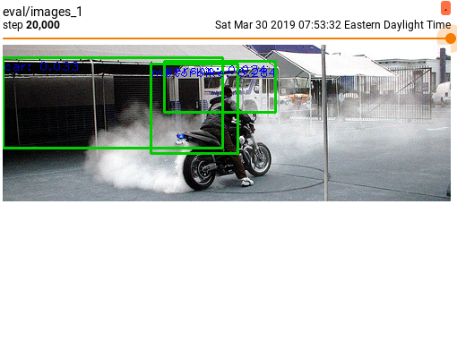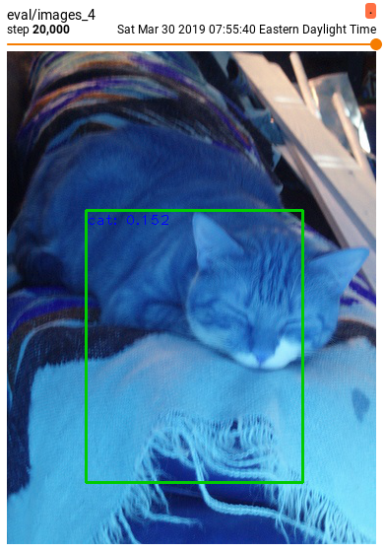

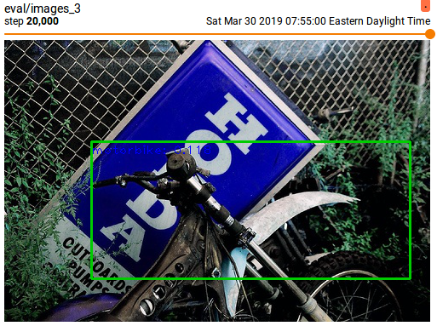

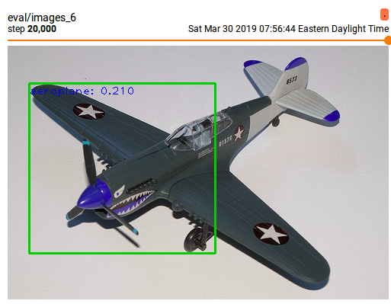

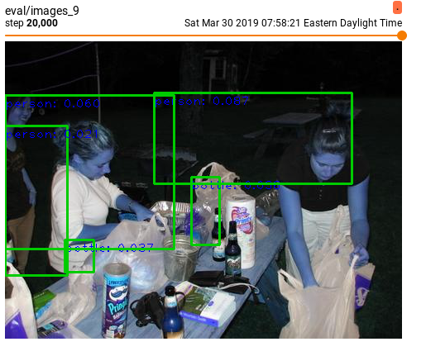

* [ ] Q2.4 report final classwise APs on the test set and mAP on the test set

